VMware HCX migration cheatsheet
Note: This document is written with the assumption that the initial HCX setup, site pairing, and L2 network stretch steps have already been completed
- Login to the SOURCE vSphere web client that has been connected to AVS through HCX
- Navigate to the HCX plugin
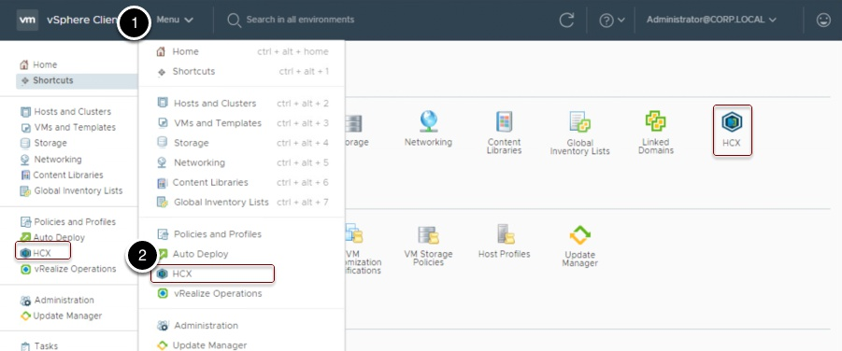
- Navigate to the migration tab on the left hand side and click “Migrate Virtual Machines”
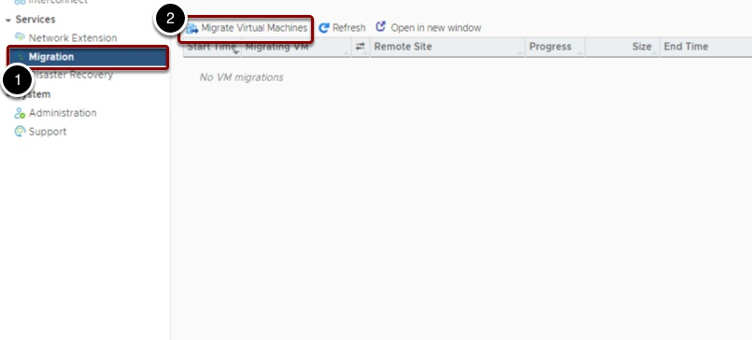
- From here you have options to choose the inventory of VMs on any site that is interconnected with the current HCX instance.
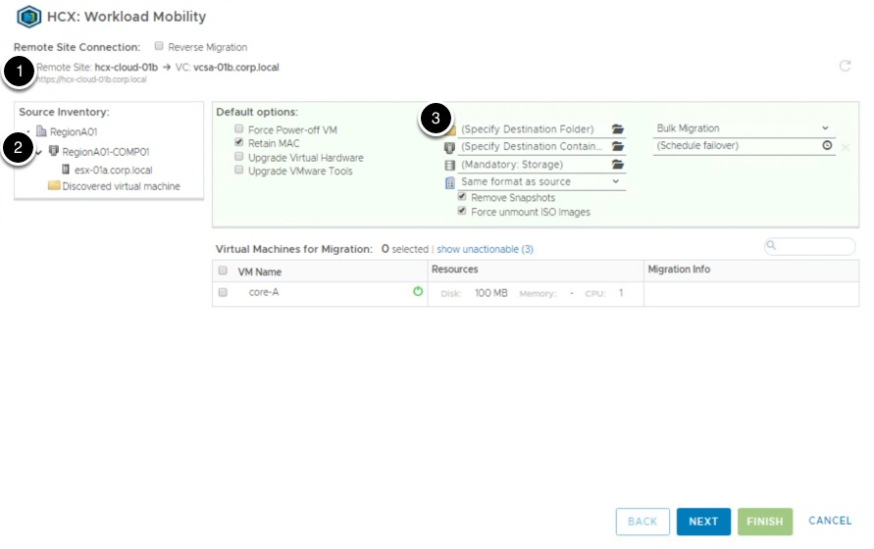
  - The default options at the top will apply to all VMs selected for migration. The settings can also be changed for each individual VM if needed.
  - Destination Folder: You can choose a Datacenter or a folder within
  - Destination Containter: This can be a cluster, ESX host, or folder
  - Storage: choose out of the datastores available on the remote site.
  - Provisioning type: you can choose to keep the source format, or force the disk provisioning type to be Thin or Thick Provision
  - Migration Type: choose between vMotion or Bulk Migration
- In the top left, you can expand the source inventory that contains the VMs you wish to migrate
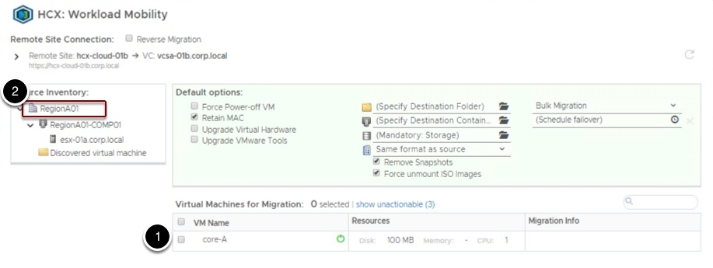
- Use the checkboxes next to the VM names to select them for migration. Expanding the VM allows you to customize the migration settings if they need to be different than the default settings shown above. You can also customize the destination network at the bottom (7)
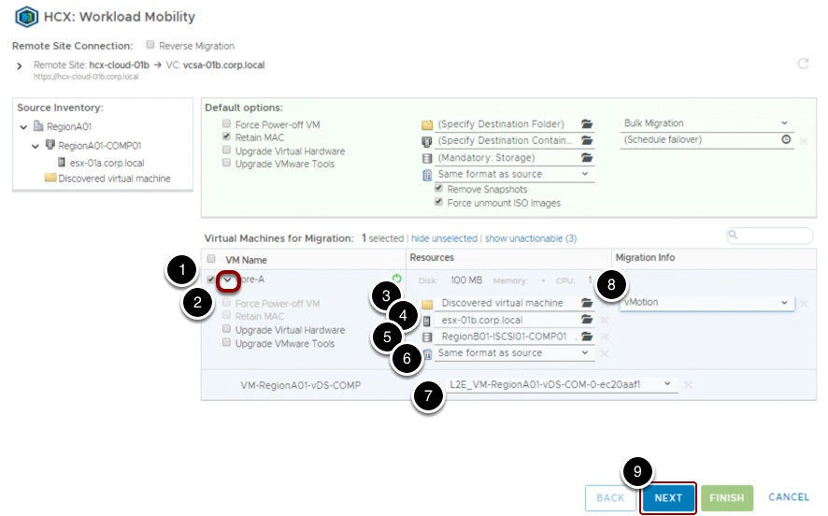
- Clicking next will bring up the Migration Validation screen. If any VMs have unspecified settings, they will be noted here. It will also give an overview of the settings for each VM that is selected to migrate
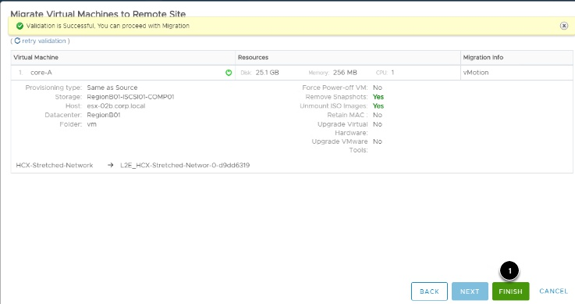
- Clicking Finish will start the migration. It will default to the migration status page, or you can navigate to it by going to the HCX menu and choosing Migration under Services.
